Forensics Detective
Aayush Nepal
3/29/2026

Summary
In this project, it takes a PDF file, reads its raw bytes as pixel values, and builds a grayscale image from that. Then machine learning classifiers try to figure out what software was used to create the PDF. Prof. Del Vecchio's Phase 1 work showed this approach hits 97.5-100% accuracy with SVM and SGD on a small test set.
What I did for this assignment was scale things up to the full 894 image dataset, add Random Forest and XGBoost as additional classifiers, and then apply five different image augmentations to see how robust the classifiers actually are. The short version: worked amazingly well on clean images (with 99.9% accuracy), but they completely fall apart when you crop the images. Even removing just 1-3% off the borders can drop down the accuracy to around 60%, which was not good for a proper forensics detective system.
Background
What is the problem?
In digital forensics there are times when you need to know what software was used to make a PDF. Usually, we look at the metadata like Creator field, XMP streams, and others. But these metadata can be easily faked and can sometimes be misleading.
This project takes a completely different approach. Instead of looking at metadata, we read the raw bytes of the PDF file and use each byte value as a pixel to make a grayscale image. Different PDF generators (Word, Google Docs, ReportLab) handle things like compression, fonts, and object serialization differently, so their binary output has different patterns. Those patterns are seen in the images, and it turns out classifiers can be trained so that they can learn to differentiate them all.
Why Test Robustness?
In a real forensic setting, documents might go through all kinds of processing like getting scanned, compressed for email, copied at low resolution, and many more. If the classifiers break down under these conditions, the approach would not be very practical.
That is what this assignment tests. I have applied five kinds of distortions that simulate real world scenarios and see how much the classifiers degrade. And see if the classifiers works or break in these scenarios.
Methodology
Dataset
The dataset was created by the professor which was originally from Wikipedia articles that were converted to PDFs using three of the following tools:
Class | How it was made | Count
Word | Exported as PDF from Microsoft Word | 398
Google | Downloaded as PDF from Google Docs | 396
Python | Generated with Python's ReportLab library | 100
Total |  | 894

Each PDF was already converted to a grayscale binary image (provided in the repo) which I resized all images to 200x200 pixels to get consistent 40,000 dimensional feature vectors from the image.
The class sizes are not perfectly balanced for example the Python class only has 100 samples vs 400+ for the others. I used stratified splitting to keep the proportions consistent for the training and testing.
Preprocessing
Before training, I ran the features through two steps:
- Standard Scaler: normalizes each pixel position to zero mean and unit variance. Without this, some positions with higher raw values would dominate the distance calculations.
- PCA: reduces from 40,000 dimensions down to one hundred principal components. This only captures 25.5% of the total variance, which sounds low, but makes sense given how high-entropy PDF binary data is. The important structural patterns are in those top components.
Augmentations
After preprocessing the data, I have applied five augmentations, each one independently to every original image. So, each image gets 5 augmented copies, making the total dataset 6x the original (894 + 4,470 = 5,364 images).
Augmentation | What it does | Real-world analog
Gaussian Noise | Adds random noise, σ between 5-20 | Scanner sensor noise
JPEG Compression | Re-encodes at quality 20-80 | Email/web compression
DPI Down sampling | Scales down to 150 or 72 dpi then back up | Low-res scanning
Random Crop | Removes 1-3% from each border | Physical scan misalignment
Bit Depth Reduction | Drops from 256 to 16 intensity levels | Low-quality hardware

One thing worth noting for DPI and cropping wat that I have resized the image back to the original dimensions after the distortion. This was necessary because the classifiers expect a fixed length feature vector (40,000 pixels = 200x200).
For the JPEG augmentation I save to actual JPEG format first (to get real quantization artifacts) then convert them back to PNG for consistent loading.
Classifiers
I used the two baseline classifiers from Phase 1 plus two additional ones:
Baseline (from Phase 1):
- SVM: Support Vector Machine with RBF kernel, C=1.0. Good at finding non-linear boundaries.
- SGD: Stochastic Gradient Descent with logistic loss. It is just a fast linear classifier.
The two I added:
- Random Forest: Uses one hundred decision trees that are each trained on a random subset of the data, then they take a majority vote. I picked this because it handles noise well and it is different from the linear methods.
- XGBoost: Gradient Boosting, where trees are built one after another and each one tries to fix the mistakes of the ones before it. I chose this since it usually does well on structured data type like our flattened pixel vectors.
All models are trained only on the original images (80/20 split, 715 train / 179 test). The augmented images are used only for evaluation, this way the robust results reflect actual domain shift, not just whether the model memorized the distortions.
Results
4.1 Baseline (Original Images)
On clean, unmodified images, all four classifiers do exceptionally well:
Classifier | Accuracy | Precision | Recall | F1
SVM | 99.89% | 99.92% | 99.92% | 99.92%
SGD | 99.89% | 99.92% | 99.92% | 99.92%
Random Forest | 99.66% | 99.75% | 99.75% | 99.75%
XGBoost | 99.78% | 99.83% | 99.83% | 99.83%

The confusion matrices below show how clean the classifications are on original data perfect diagonal:
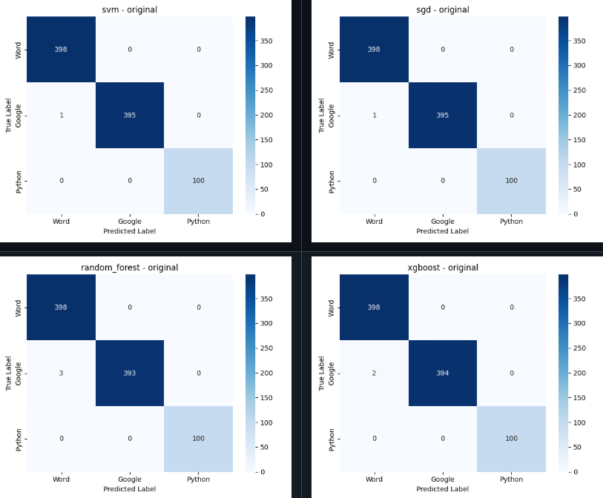

The numbers are really good in these figures, The fact that even a simple linear model (SGD) hits 99.89% tells us that class boundaries in PCA space are very clean. The PDF generators really do leave distinct binary fingerprints
Robustness Results
Here's where it gets interesting:
Condition | SVM | SGD | Random Forest | XGBoost
Original | 99.89% | 99.89% | 99.66% | 99.78%
Gaussian | 99.89% | 99.89% | 99.66% | 99.78%
JPEG | 99.89% | 99.89% | 99.55% | 99.66%
DPI | 72.37% | 97.87% | 91.61% | 96.42%
Crop | 59.51% | 66.00% | 60.74% | 67.23%
Bit-depth | 99.89% | 96.98% | 99.55% | 98.55%
The robustness curve below shows how each classifier's accuracy changes across conditions:
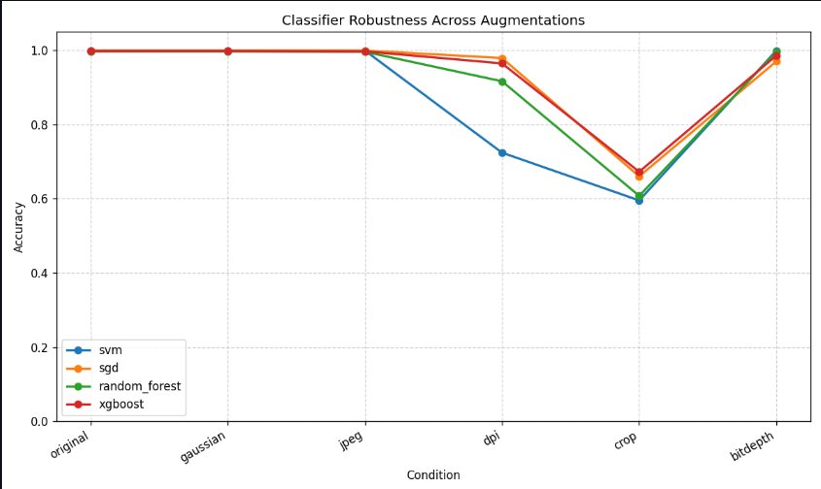

What Do These Numbers Mean?
Gaussian noise and JPEG compression barely matter. All classifiers manage them without any real degradation. The structural patterns in the binary images are so strong that adding noise or compressing does not disrupt them. After PCA, the noise gets pushed into low-variance components that classifiers basically ignore.
DPI downsampling hits SVM hard. SVM drops from 99.89% all the way to 72.37%, while SGD barely flinches (97.87%). The other classifiers fall somewhere in between.
what is happening is that DPI downsampling introduces systematic interpolation artifacts pixels get averaged together during the downscale, then nearest-neighbor creates blocky patterns on the upscale. SVM with RBF kernel is really sensitive to how far data points are from the support vectors, and these systematic shifts push the data points across the decision boundary. SGD's linear surface seems more tolerant of this kind of uniform shift.
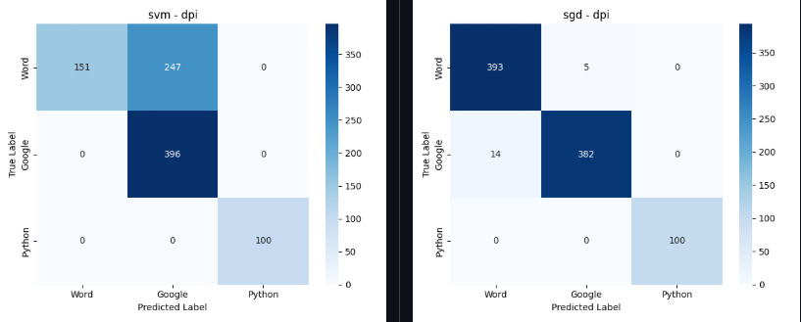

Cropping destroys everything. This is the biggest finding. All four classifiers collapse:
- SVM: 99.89% → 59.51% (down 40 points)
- SGD: 99.89% → 66.00% (down 34 points)
- RF: 99.66% → 60.74% (down 39 points)
- XGBoost: 99.78% → 67.23% (down 33 points)
The reason is clear when you think about it. The images are flattened into 1D vectors, so pixel position is equal to array index. When you crop even 1-3% off the border and resize back up, every single pixel shift position. The entire feature vector gets misaligned with what the classifiers learned. It is like sliding a ruler and everything shifts over.
The fact that accuracy stays above 59% (vs 33% random chance for three classes) means some signal survives, but it is really degraded.
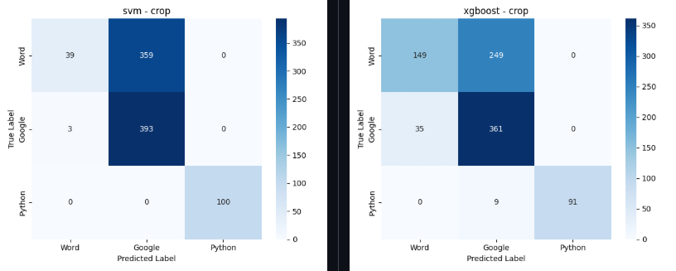
Bit-depth reduction is mostly fine. Dropping from 256 intensity levels to sixteen does not affect SVM or RF much. SGD takes a small hit (96.98%) which might be because the linear weights depend more on fine intensity gradients.
Statistical Significance
I ran McNemar's test to compare each pair of classifiers on the original data:
Model A | Model B | Statistic | p-value | Significant?
SVM | SGD | 0.000 | 1.000 | No
SVM | RF | 0.500 | 0.480 | No
SVM | XGBoost | 0.000 | 1.000 | No
SGD | RF | 0.500 | 0.480 | No
SGD | XGBoost | 0.000 | 1.000 | No
RF | XGBoost | 0.000 | 1.000 | No

None of the differences are statistically significant, which makes sense when all classifiers are getting 99.7-99.9% accuracy, there are maybe 1-3 samples where they disagree. McNemar's test just does not have enough disagreement events to work with at this accuracy level. It does not mean the classifiers are identical, just that we will need a much bigger test dataset to detect the differences.
Discussion
Practical Implications
So, the good news is that for documents that have not been through any physical processing (like scanning or printing), this approach works really well. JPEG compression and noise do not hurt it at all, which is nice because those are common things that happen when documents get emailed or downloaded.
The bad news is that the whole approach kind of breaks down when spatial stuff changes. Because were flattening images into 1D vectors, cropping even a tiny amount messes up all the pixel positions and the classifiers cannot manage it. In a real investigation you cannot really guarantee that a document has not been cropped up or scanned a little off-center, so that is a big limitation.
What Would Fix the Crop Problem?
I think the natural next step would be trying CNN. The whole reason our classifiers break under cropping is because they were treating images as flat 1D vectors where position matters. CNNs work on 2D patches, and they are designed to handle translating a small shift or crop does not really change what the CNN sees. That should fix the biggest problem we found. It would be interesting to see if a simple CNN could maintain the 99%+ accuracy on clean images while also surviving cropping.
Classifier Recommendations
Based on the results:
- For clean documents: any of the four classifiers works, pick the fastest (SGD)
- For potentially scanned documents: avoid SVM, use SGD or XGBoost
- For potentially cropped documents: none of these classifiers are reliable, need a different approach (CNN)
Conclusion
To wrap up I took the Forensics Detective approach and scaled it to the full dataset (894 images, three classes), built a six times augmented version (5,364 total), trained four classifiers, and tested everything.
The main things I found:
- On clean images all four classifiers get ~99.9% accuracy, which is honestly insane. The binary signatures are very real.
- Gaussian noise, JPEG compression, and bit-depth reduction do not really matter much. The classifiers handle them fine.
- DPI downsampling is interesting because it affects different classifiers differently. SVM tanks to 72% but SGD stays at 98%.
- Cropping breaks everything. All classifiers drop to 59-67% because the flattened feature vectors get misaligned.
- The McNemar tests show no significant differences between classifiers on clean data, but that is mostly because they are all so accurate that there is basically no disagreement with the test.
Overall, the binary-to-image approach clearly works for PDF forensics when documents are clean, but the spatial robustness issue with cropping is a real problem that would need CNNs or some other 2D-aware approach to solve.

References
- "Digital Forensics for Malware Classification: Binary Visualization Approach." Computational Intelligence and Neuroscience, 2022. https://pmc.ncbi.nlm.nih.gov/articles/PMC9050294/
- "PDF Malware Detection Using Machine Learning." IEEE, 2024. https://ieeexplore.ieee.org/document/10412055/
- "Analyzing PDFs like Binaries: Adversarially Robust PDF Malware Analysis." arXiv, 2025. https://arxiv.org/html/2506.17162
- "PDF Forensic Analysis and XMP Metadata." Meridian Discovery. https://www.meridiandiscovery.com/articles/pdf-forensic-analysis-xmp-metadata/
- Scikit-learn Documentation SVM, SGD, Random Forest, PCA. https://scikit-learn.org/stable/
- Chen & Guestrin, "XGBoost: A Scalable Tree Boosting System." KDD 2016. https://arxiv.org/abs/1603.02754
- McNemar, Q. "Note on the sampling error of the difference between correlated proportions." Psychometrika, 1947.
- "PDF Forensics and the Metadata Conundrum." PDF Association. https://pdfa.org/presentation/pdf-forensics-and-the-metadata-conundrum/

